Project Design Phase-II
Data Flow Diagram & User Stories

Date | 17 July 2026
Team ID
Project Name | CUSTOMER REGISTRY
Maximum Marks | 4 Marks

Data Flow Diagrams:
A Data Flow Diagram (DFD) illustrates how data moves through the Customer Registry System. It represents the interaction between users, processes, and the database, showing how customer information, complaints, and reports are processed and stored. The DFD helps stakeholders understand the system's workflow and data movement.

Example: (Simplified)
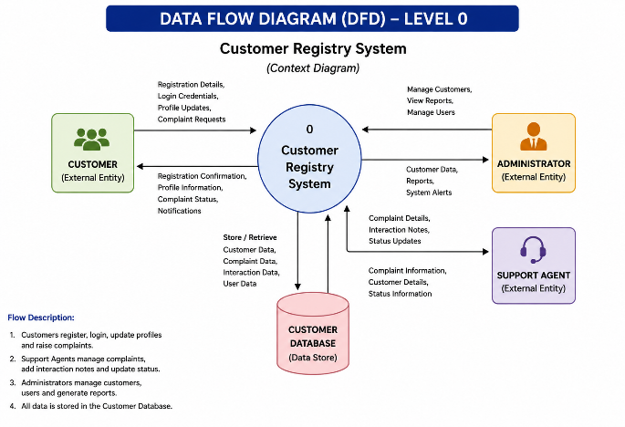


User Stories
Use the below template to list all the user stories for the product.
User Type | Functional Requirement (Epic) | User Story Number | User Story / Task | Acceptance Criteria | Priority | Release
Customer | Registration | USN-1 | As a customer, I can register by entering my personal details. | Registration is completed successfully and customer account is created. | High | Sprint-1
Customer | Login | USN-2 | As a customer, I can log in using my email and password. | User is redirected to the dashboard after successful login. | High | Sprint-1
Administrator | Customer Management | USN-3 | As an administrator, I can add new customer records. | Customer information is stored successfully. | High | Sprint-2
Administrator | Customer Management | USN-4 | As an administrator, I can edit customer details. | Updated information is saved successfully. | High | Sprint-2
Administrator | Customer Management | USN-5 | As an administrator, I can delete customer records. | Selected customer record is removed successfully. | Medium | Sprint-2
Support Agent | Complaint Management | USN-6 | As a support agent, I can create and manage customer complaints. | Complaint is created and tracked successfully. | High | Sprint-3
Support Agent | Interaction Management | USN-7 | As a support agent, I can record customer interactions. | Interaction history is saved correctly. | Medium | Sprint-3
Administrator | Dashboard | USN-8 | As an administrator, I can view dashboard statistics and reports. | Dashboard displays customer and complaint summaries. | High | Sprint-4
Administrator | Reports | USN-9 | As an administrator, I can generate customer reports. | Reports are generated successfully. | Medium | Sprint-4
Administrator | Security | USN-10 | As an administrator, I can manage user roles and permissions. | Only authorized users can access protected modules. | Medium | Sprint-4
Customer | Registration | USN-1 | As a customer, I can register by entering my personal details. | Registration is completed successfully and customer account is created. | High | Sprint-1
Customer | Login | USN-2 | As a customer, I can log in using my email and password. | User is redirected to the dashboard after successful login. | High | Sprint-1
Administrator | Customer Management | USN-3 | As an administrator, I can add new customer records. | Customer information is stored successfully. | High | Sprint-2
Administrator | Customer Management | USN-4 | As an administrator, I can edit customer details. | Updated information is saved successfully. | High | Sprint-2

